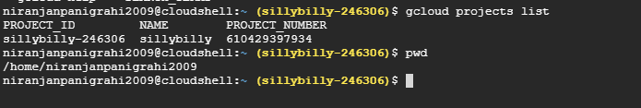

Git , java ,python and other tools are already installed.

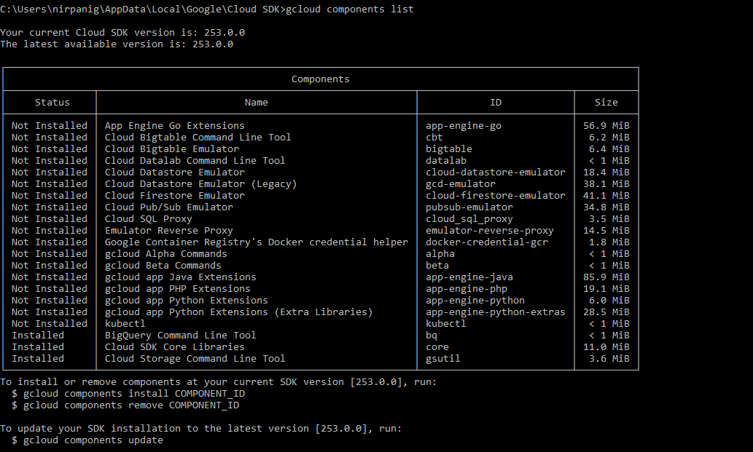

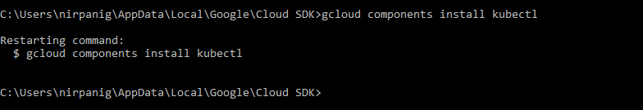

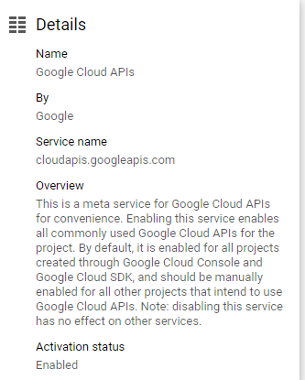

C:\Users\nirpanig\AppData\Local\Google\Cloud SDK>gcloud services list --available

NAME TITLE

abusiveexperiencereport.googleapis.com Abusive Experience Report API

acceleratedmobilepageurl.googleapis.com Accelerated Mobile Pages (AMP) URL API

accessapproval.googleapis.com Access Approval API

accesscontextmanager.googleapis.com Access Context Manager API

actions.googleapis.com Actions API

adexchangebuyer-json.googleapis.com Ad Exchange Buyer API

adexchangebuyer.googleapis.com Ad Exchange Buyer API II

adexchangeseller.googleapis.com Ad Exchange Seller API

adexperiencereport.googleapis.com Ad Experience Report API

admin.googleapis.com Admin SDK

adsense.googleapis.com AdSense Management API

adsensehost.googleapis.com AdSense Host API

alertcenter.googleapis.com G Suite Alert Center API

analytics.googleapis.com Google Analytics API

analyticsreporting.googleapis.com Analytics Reporting API

androidcheck.googleapis.com Android Device Verification

androiddeviceprovisioning.googleapis.com Android Device Provisioning Partner API

androidenterprise.googleapis.com Google Play EMM API

androidmanagement.googleapis.com Android Management API

androidovertheair.googleapis.com Android Over the Air API

androidpublisher.googleapis.com Google Play Android Developer API

apikeys.googleapis.com API Keys API

appengine.googleapis.com App Engine Admin API

appengineflex.googleapis.com Google App Engine Flexible Environment

appsactivity.googleapis.com Apps Activity API

appsmarket-component.googleapis.com G Suite Marketplace SDK

appsmarket.googleapis.com G Suite Marketplace API

arcorecloudanchor.googleapis.com ARCore Cloud Anchor API

audit.googleapis.com Audit API

automl.googleapis.com Cloud AutoML API

bigquery-json.googleapis.com BigQuery API

bigquerydatatransfer.googleapis.com BigQuery Data Transfer API

bigquerystorage.googleapis.com BigQuery Storage API

bigtable.googleapis.com Cloud Bigtable API

bigtableadmin.googleapis.com Cloud Bigtable Admin API

bigtabletableadmin.googleapis.com Cloud Bigtable Table Admin API

binaryauthorization.googleapis.com Binary Authorization API

blogger.googleapis.com Blogger API v3

books.googleapis.com Google Books API

bookstore.endpoints.endpoints-portal-demo.cloud.goog Bookstore gRPC API

caldav.googleapis.com CalDAV API

calendar-json.googleapis.com Google Calendar API

carddav.googleapis.com Google Contacts CardDAV API

chat.googleapis.com Hangouts Chat API

chromewebstore.googleapis.com Chrome Web Store API

civicinfo.googleapis.com Civic Information API

classroom.googleapis.com Google Classroom API

cloudapis.googleapis.com Google Cloud APIs

cloudasset.googleapis.com Cloud Asset API

cloudbilling.googleapis.com Cloud Billing API

cloudbuild.googleapis.com Cloud Build API

clouddebugger.googleapis.com Stackdriver Debugger API

clouderrorreporting.googleapis.com Stackdriver Error Reporting API

cloudfunctions.googleapis.com Cloud Functions API

cloudidentity.googleapis.com Cloud Identity API

cloudiot.googleapis.com Cloud IoT API

cloudkms.googleapis.com Cloud Key Management Service (KMS) API

cloudlatencytest.googleapis.com Cloud Network Performance Monitoring API

cloudmonitoring.googleapis.com Cloud Monitoring API

cloudprivatecatalog.googleapis.com Cloud Private Catalog API

cloudprivatecatalogproducer.googleapis.com Cloud Private Catalog Producer API

cloudprofiler.googleapis.com Stackdriver Profiler API

cloudresourcemanager.googleapis.com Cloud Resource Manager API

cloudscheduler.googleapis.com Cloud Scheduler API

cloudsearch.googleapis.com Cloud Search API

cloudshell.googleapis.com Cloud Shell API

cloudtasks.googleapis.com Cloud Tasks API

cloudtrace.googleapis.com Stackdriver Trace API

commentanalyzer.googleapis.com Perspective Comment Analyzer API

composer.googleapis.com Cloud Composer API

compute.googleapis.com Compute Engine API

contacts.googleapis.com Contacts API

container.googleapis.com Kubernetes Engine API

containeranalysis.googleapis.com Container Analysis API

containerregistry.googleapis.com Container Registry API

containerscanning.googleapis.com Container Scanning API

copresence.googleapis.com Nearby Messages API

customsearch.googleapis.com Custom Search API

datacatalog.googleapis.com Google Cloud Data Catalog API

dataflow.googleapis.com Dataflow API

datafusion.googleapis.com Cloud Data Fusion API

datalabeling.googleapis.com Data Labeling API

dataproc.googleapis.com Cloud Dataproc API

datastore.googleapis.com Cloud Datastore API

deploymentmanager.googleapis.com Cloud Deployment Manager V2 API

dfareporting.googleapis.com DCM/DFA Reporting And Trafficking API

dialogflow.googleapis.com Dialogflow API

digitalassetlinks.googleapis.com Digital Asset Links API

directions-backend.googleapis.com Directions API

discovery.googleapis.com API Discovery Service

distance-matrix-backend.googleapis.com Distance Matrix API

dlp.googleapis.com Cloud Data Loss Prevention (DLP) API

dns.googleapis.com Google Cloud DNS API

docs.googleapis.com Google Docs API

doubleclickbidmanager.googleapis.com DoubleClick Bid Manager API

doubleclicksearch.googleapis.com DoubleClick Search API

drive.googleapis.com Google Drive API

driveactivity.googleapis.com Drive Activity API

echo-api.endpoints.endpoints-portal-demo.cloud.goog Endpoints Example

elevation-backend.googleapis.com Maps Elevation API

embeddedassistant.googleapis.com Google Assistant API

endpoints.googleapis.com Google Cloud Endpoints

endpointsportal.googleapis.com Cloud Endpoints Portal

factchecktools.googleapis.com Fact Check Tools API

fcm.googleapis.com Firebase Cloud Messaging API

file.googleapis.com Cloud Filestore API

firebase.googleapis.com Firebase Management API

firebaseappdistribution.googleapis.com Firebase App Distribution API

firebasedynamiclinks.googleapis.com Firebase Dynamic Links API

firebasehosting.googleapis.com Firebase Hosting API

firebaseinappmessaging.googleapis.com Firebase In-App Messaging API

firebaseinstallations.googleapis.com Firebase Installations API

firebaseremoteconfig.googleapis.com Firebase Remote Config API

firebaserules.googleapis.com Firebase Rules API

firestore.googleapis.com Cloud Firestore API

fitness.googleapis.com Fitness API

freebase.googleapis.com Freebase API

fusiontables.googleapis.com Fusion Tables API

games.googleapis.com Google Play Game Services

gamesconfiguration.googleapis.com Google Play Game Services Publishing API

gamesmanagement.googleapis.com Google Play Game Management

genomics.googleapis.com Genomics API

geocoding-backend.googleapis.com Geocoding API

geolocation.googleapis.com Geolocation API

gmail.googleapis.com Gmail API

googleads.googleapis.com Google Ads API

googlecloudmessaging.googleapis.com Cloud Messaging

groupsmigration.googleapis.com Groups Migration API

groupssettings.googleapis.com Groups Settings API

healthcare.googleapis.com Cloud Healthcare API

homegraph.googleapis.com HomeGraph API

iam.googleapis.com Identity and Access Management (IAM) API

iamcredentials.googleapis.com IAM Service Account Credentials API

iap.googleapis.com Cloud Identity-Aware Proxy API

identitytoolkit.googleapis.com Identity Toolkit API

indexing.googleapis.com Indexing API

istioca.googleapis.com Istio Certificate Authority API

jobs.googleapis.com Cloud Talent Solution API

kgsearch.googleapis.com Knowledge Graph Search API

language.googleapis.com Cloud Natural Language API

libraryagent.googleapis.com Library Agent API

licensing.googleapis.com Enterprise License Manager API

logging.googleapis.com Stackdriver Logging API

managedidentities.googleapis.com Managed Service for Microsoft Active Directory API

manufacturers.googleapis.com Manufacturer Center API

maps-android-backend.googleapis.com Maps SDK for Android

maps-backend.googleapis.com Maps JavaScript API

maps-embed-backend.googleapis.com Maps Embed API

maps-ios-backend.googleapis.com Maps SDK for iOS

migrate.googleapis.com G Suite Migrate API

mirror.googleapis.com Mirror API

ml.googleapis.com Cloud Machine Learning Engine

mlkit.googleapis.com ML Kit API

mobilecrashreporting.googleapis.com Mobile Crash Reporting API

monitoring.googleapis.com Stackdriver Monitoring API

moviesanywhere.googleapis.com Play Movies Anywhere API

orkut.googleapis.com Orkut REST API

osconfig.googleapis.com Cloud OS Config API

oslogin.googleapis.com Cloud OS Login API

pagespeedonline.googleapis.com PageSpeed Insights API

partners-json.googleapis.com Google Partners API

people.googleapis.com People API

photoslibrary.googleapis.com Photos Library API

picker.googleapis.com Google Picker API

places-backend.googleapis.com Places API

playcustomapp.googleapis.com Google Play Custom App Publishing API

plus.googleapis.com Google+ API

plusdomains.googleapis.com Google+ Domains API

plushangouts.googleapis.com Google+ Hangouts API

poly.googleapis.com Poly API

proximitybeacon.googleapis.com Proximity Beacon API

pubsub.googleapis.com Cloud Pub/Sub API

realtime.googleapis.com Realtime API

redis.googleapis.com Google Cloud Memorystore for Redis API

remotebuildexecution.googleapis.com Remote Build Execution API

replicapool.googleapis.com Compute Engine Instance Group Manager API

replicapoolupdater.googleapis.com Compute Engine Instance Group Updater API

reseller.googleapis.com Google Apps Reseller API

resourceviews.googleapis.com Compute Engine Instance Groups API

risc.googleapis.com RISC API

roads.googleapis.com Roads API

run.googleapis.com Cloud Run API

runtimeconfig.googleapis.com Cloud Runtime Configuration API

safebrowsing-json.googleapis.com Safe Browsing API (Legacy)

safebrowsing.googleapis.com Safe Browsing API

script.googleapis.com Apps Script API

searchconsole.googleapis.com Google Search Console URL Testing Tools API

securetoken.googleapis.com Token Service API

securitycenter.googleapis.com Cloud Security Command Center API

servicebroker.googleapis.com Service Broker API

serviceconsumermanagement.googleapis.com Service Consumer Management API

servicecontrol.googleapis.com Service Control API

servicemanagement.googleapis.com Service Management API

servicenetworking.googleapis.com Service Networking API

serviceusage.googleapis.com Service Usage API

sheets.googleapis.com Google Sheets API

shoppingcontent.googleapis.com Content API for Shopping

siteverification.googleapis.com Site Verification API

slides.googleapis.com Google Slides API

sourcerepo.googleapis.com Cloud Source Repositories API

spanner.googleapis.com Cloud Spanner API

speech.googleapis.com Cloud Speech-to-Text API

sql-component.googleapis.com Cloud SQL

sqladmin.googleapis.com Cloud SQL Admin API

stackdriver.googleapis.com Stackdriver API

static-maps-backend.googleapis.com Maps Static API

storage-api.googleapis.com Google Cloud Storage JSON API

storage-component.googleapis.com Cloud Storage

storagetransfer.googleapis.com Storage Transfer API

street-view-image-backend.googleapis.com Street View Static API

streetviewpublish.googleapis.com Street View Publish API

subscribewithgoogle.googleapis.com Subscribe with Google Publication API

subscribewithgoogledeveloper.googleapis.com Subscribe with Google Developer API

surveys.googleapis.com Surveys API

tagmanager.googleapis.com Tag Manager API

tasks.googleapis.com Tasks API

testing.googleapis.com Cloud Testing API

texttospeech.googleapis.com Cloud Text-to-Speech API

timezone-backend.googleapis.com Time Zone API

toolresults.googleapis.com Cloud Tool Results API

tpu.googleapis.com Cloud TPU API

trafficdirector.googleapis.com Traffic Director API

translate.googleapis.com Cloud Translation API

travelpartner.googleapis.com Travel Hotel Ads API

urlshortener.googleapis.com URL Shortener API

usercontext.googleapis.com Awareness API

vault.googleapis.com G Suite Vault API

videointelligence.googleapis.com Cloud Video Intelligence API

vision.googleapis.com Cloud Vision API

vmmigration.googleapis.com VM Migration API

vpcaccess.googleapis.com Serverless VPC Access API

walletobjects.googleapis.com Google Pay Passes API

webfonts.googleapis.com Web Fonts Developer API

webmasters.googleapis.com Google Search Console API

websecurityscanner.googleapis.com Web Security Scanner API

youtube.googleapis.com YouTube Data API v3

youtubeadsreach.googleapis.com YouTube Ads Reach API

youtubeanalytics.googleapis.com YouTube Analytics API

youtubereporting.googleapis.com YouTube Reporting API

zync.googleapis.com Zync Render API

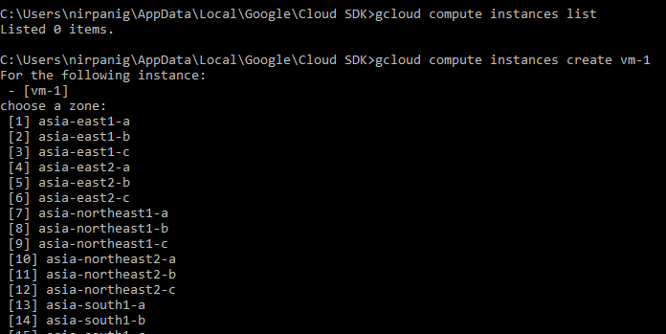





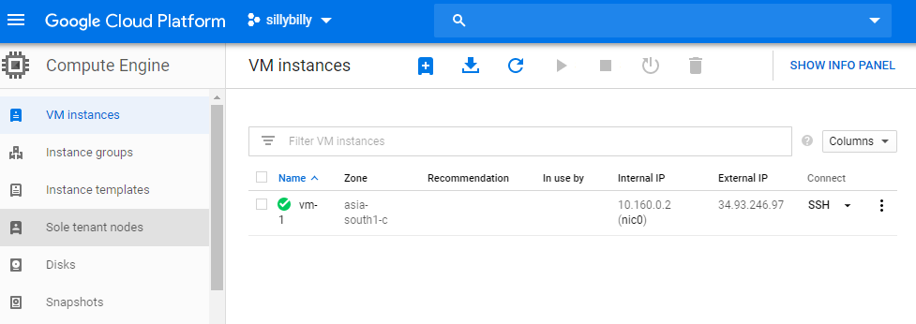

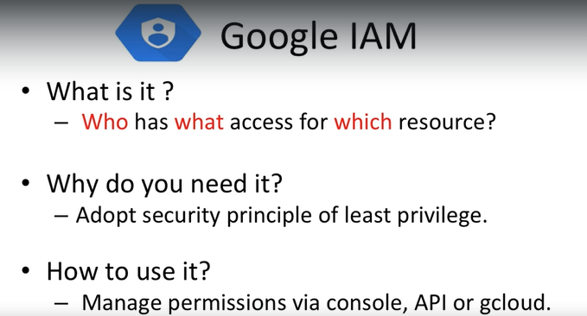

<https://console.cloud.google.com/home/dashboard?project=sillybilly-246306>

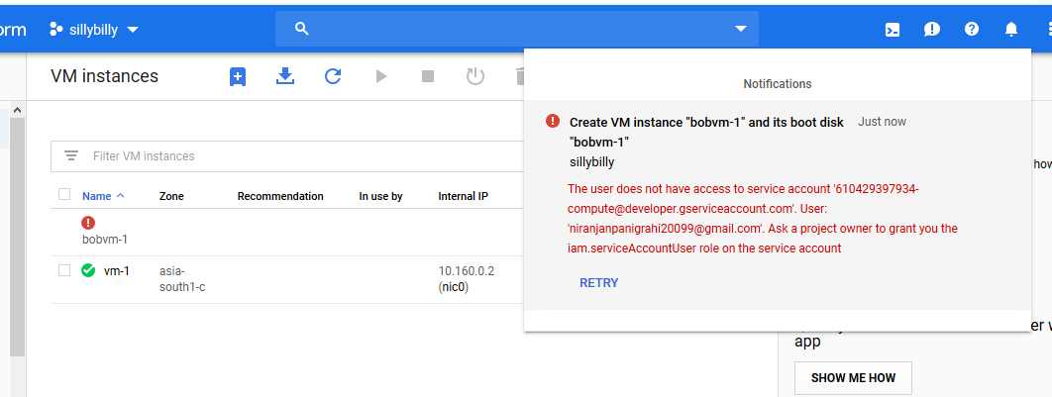

<https://cloud.google.com/iam/docs/granting-roles-to-service-accounts?_ga=2.85536345.-1749581876.1562054148>

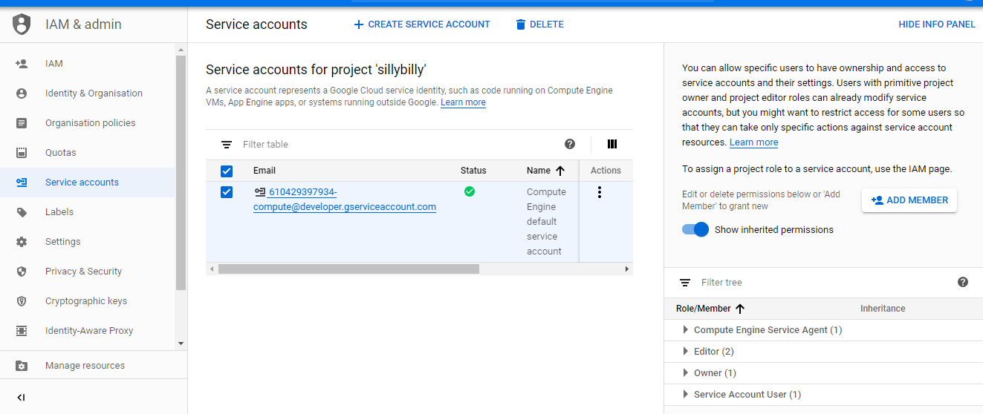

**Custom role**

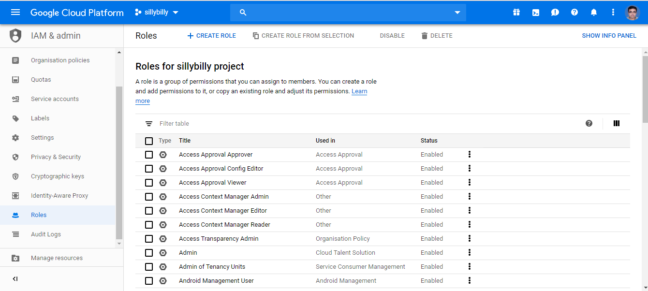

Trying to create a vm with http and https enabled from bob’s account. It will fail because does not have necessary permission to change the firewall settings. These permissions can only be given by admin to bob.

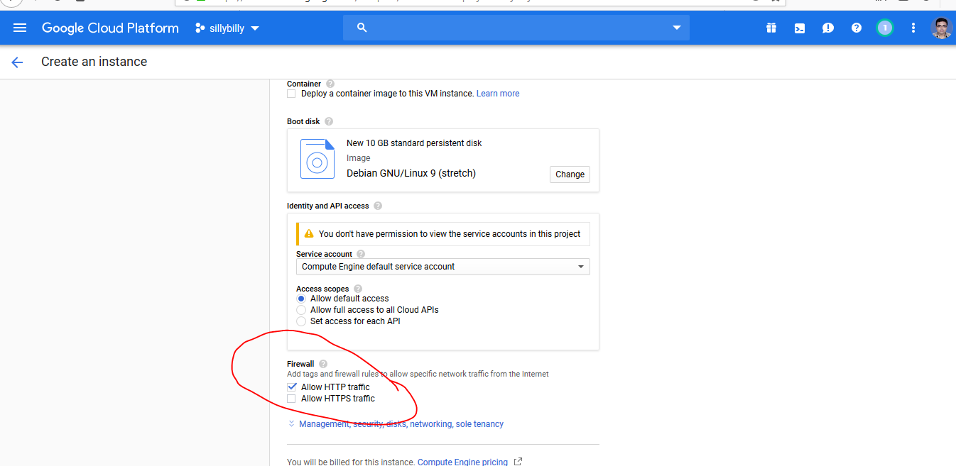

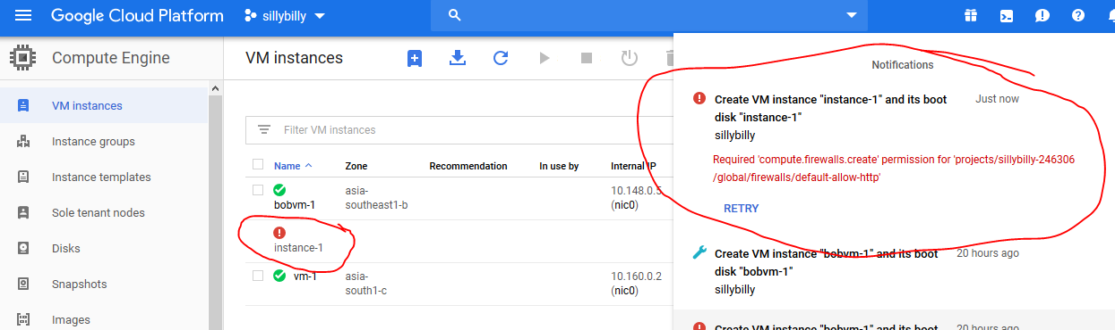

After creating custom rule (bothttprule-allow) and adding permission related to network and firewall bob was able to create vm with http/https enabled.



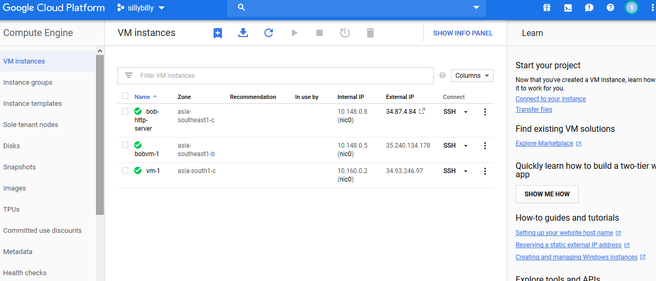

Bob does not have permission to create firewall rule from the portal.

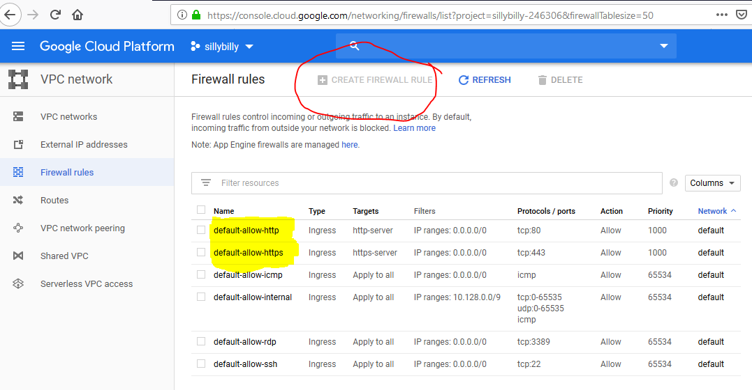

Firewall rule can be created from the command prompt.

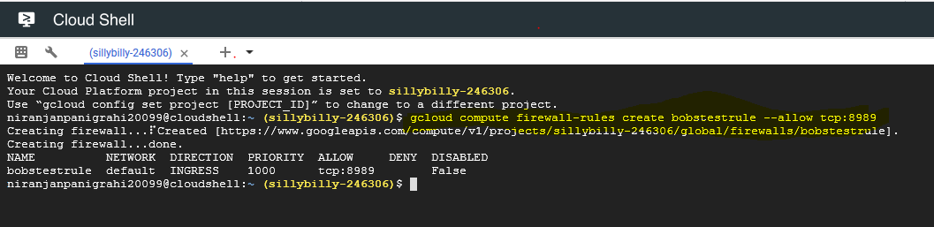

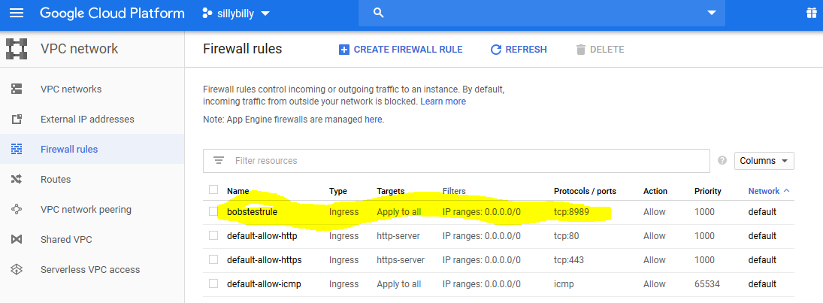

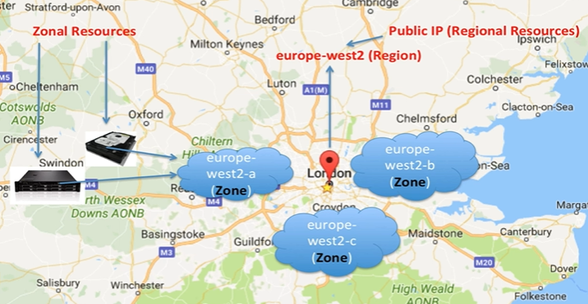

gcloud compute --project=sillybilly-246306 instances create bobsdatabase-server --zone=asia-southeast1-b --machine-type=custom-1-1024 --subnet=default --network-tier=PREMIUM --metadata=production=finance\ database\ server,startup-script=\#\!\ /bin/bash$'\n'apt-get\ update$'\n'apt-get\ install\ -y\ apache2$'\n'cat\ \<\<EOF\ \>\ /var/www/html/index.html$'\n'\<html\>\<body\>\<h1\>Hello\ World\</h1\>$'\n'\<p\>This\ page\ was\ created\ from\ a\ simple\ startup\ script\!\</p\>$'\n'\</body\>\</html\>$'\n'EOF --no-restart-on-failure --maintenance-policy=TERMINATE --preemptible --service-account=610429397934-compute@developer.gserviceaccount.com --scopes=https://www.googleapis.com/auth/devstorage.read_only,https://www.googleapis.com/auth/logging.write,https://www.googleapis.com/auth/monitoring.write,https://www.googleapis.com/auth/servicecontrol,https://www.googleapis.com/auth/service.management.readonly,https://www.googleapis.com/auth/trace.append --image=debian-9-stretch-v20190618 --image-project=debian-cloud --boot-disk-size=10GB --boot-disk-type=pd-standard --boot-disk-device-name=bobsdatabase-server

gcloud compute --project=sillybilly-246306 instances create bobsdatabase-server --zone=asia-southeast1-b --machine-type=custom-1-1024 --subnet=default --network-tier=PREMIUM --metadata=production=finance\ database\ server,startup-script=install.sh --no-restart-on-failure --maintenance-policy=TERMINATE --preemptible --service-account=610429397934-compute@developer.gserviceaccount.com --scopes=https://www.googleapis.com/auth/devstorage.read_only,https://www.googleapis.com/auth/logging.write,https://www.googleapis.com/auth/monitoring.write,https://www.googleapis.com/auth/servicecontrol,https://www.googleapis.com/auth/service.management.readonly,https://www.googleapis.com/auth/trace.append --image=debian-9-stretch-v20190618 --image-project=debian-cloud --boot-disk-size=10GB --boot-disk-type=pd-standard --boot-disk-device-name=bobsdatabase-server

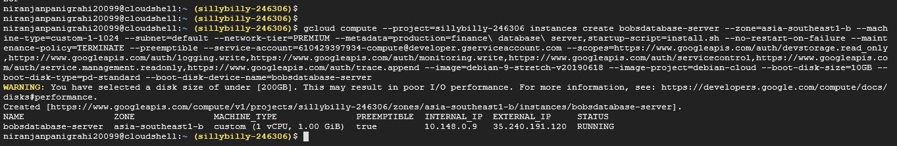

**To see all the vms available**



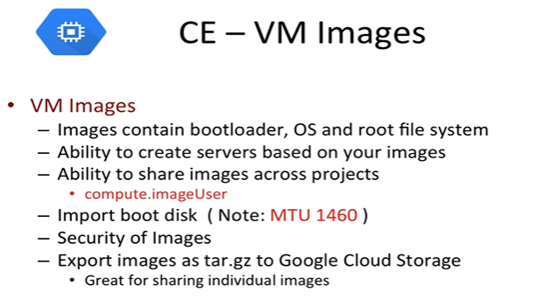

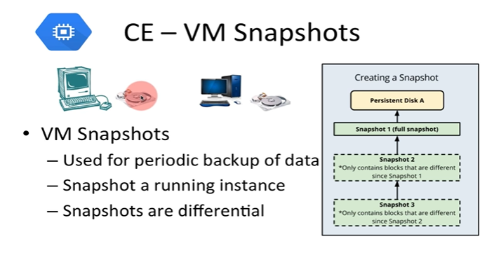

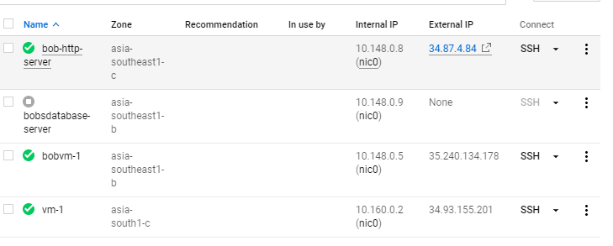

Configuring server to install apache HTTP server and php7.0 on Debian / Linux 9(stretch)

———————————————————————————————————————-

1) install apache:

apt-get install apache2 -y

apt-get install php7.0 -y

2) Move the old index.html to oldindex.html

cd /var/www/html

mv index.html oldindex.html

3) Create a index.php file

1)vi index.php

2) Type 'i' to insert text

4) Paste the following in the above index.php file

<?php

echo "Today is " . date("Y/m/d") . "<br>";

echo "The time is " . date("h:i:sa") . "<br>";

echo "You are directed to this server ->",gethostname();

?>

Note: Type :wq to write and quit

5) Now open the website type the external IP in your browser http://EXTERNALIP-OF-YOUR-INSTANCE and make sure it works in the first place.

**For bob-httpserver http/https are enabled so I am able to access the server**

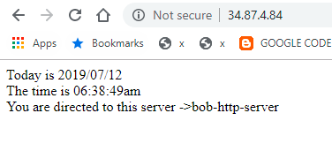

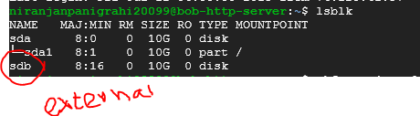

sudo mkfs.ext4 -m 0 -F -E lazy_itable_init=0,lazy_journal_init=0,discard /dev/sdb

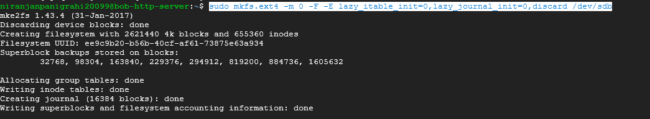

<https://cloud.google.com/compute/docs/disks/add-persistent-disk#create_disk>

**niranjanpanigrahi20099@bob-http-server**:**~**$ tail /etc/fstabUUID=ee6ea394-7ac2-4959-a423-3ec8bddda3df / ext4 defaults 1 1UUID=ee9c9b20-b56b-40cf-af61-73875e63a934 /mnt/httpdir ext4 discard,defaults,nofail 0 2

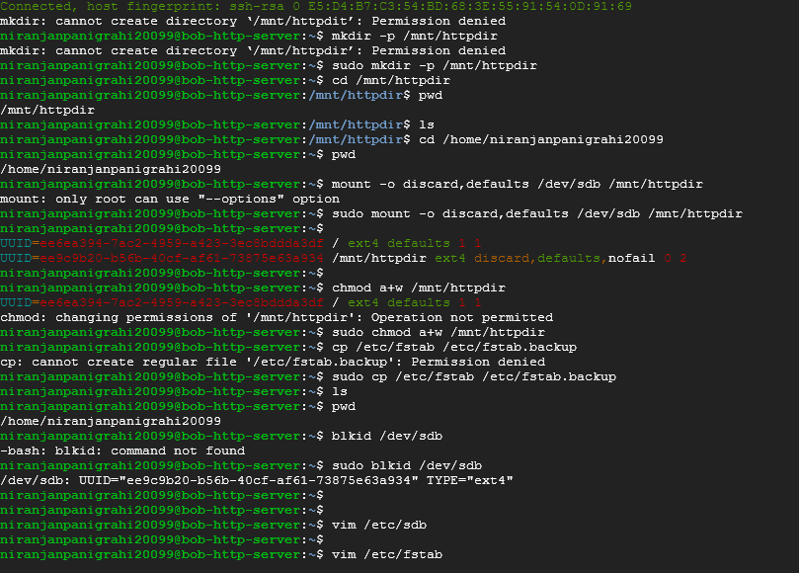

**Creating image of the disc where os is installed**

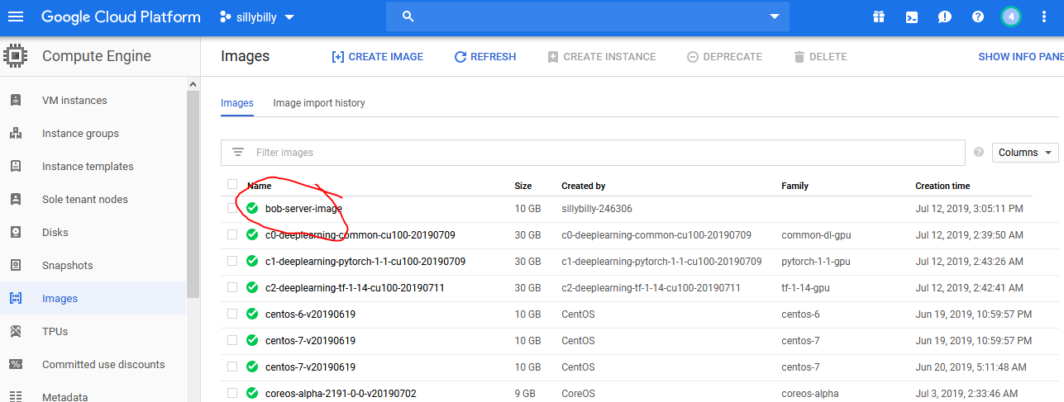

Snapshot should be created for external disc that we add to the vm.

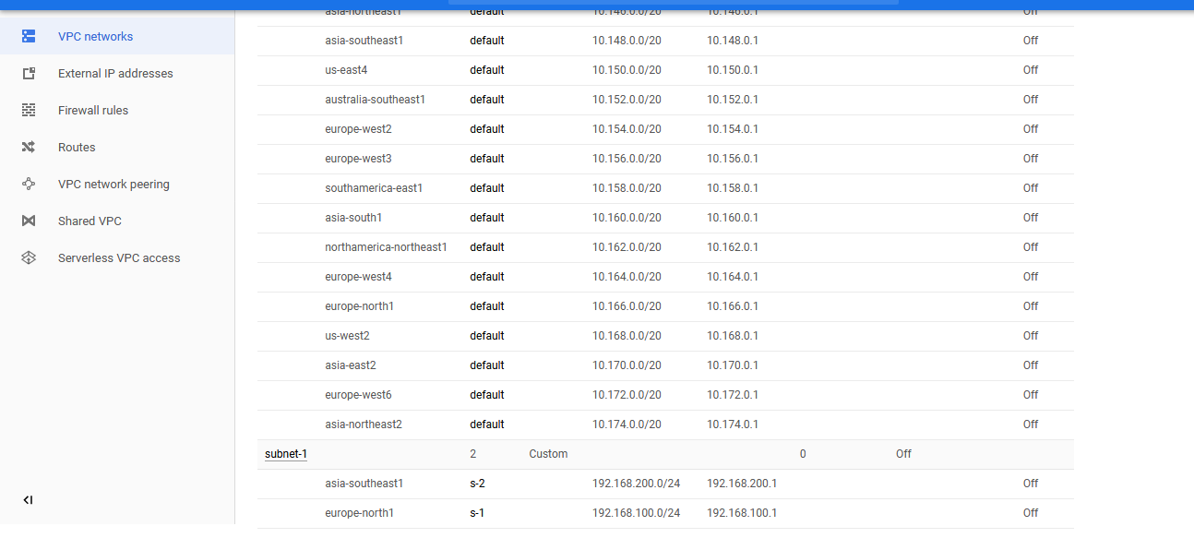

Steps for Connecting cloud sql server from vm

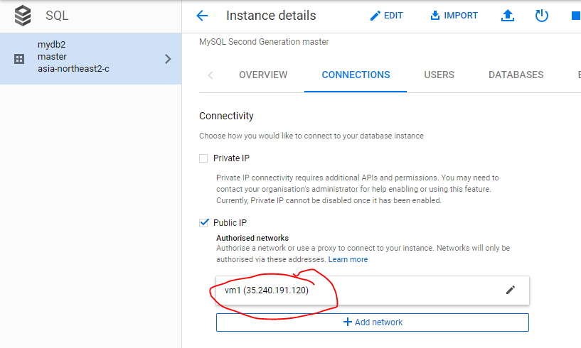

Put vm’s ip in connections tab of db.

Below programs need to be installed to connect to sqldb.

sudo apt-get update

sudo apt-get install mysql-client



Connecting cloud-sql using cloud shell.

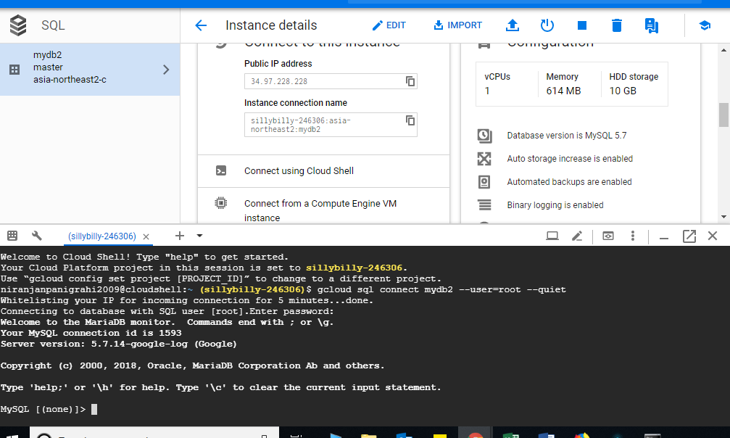

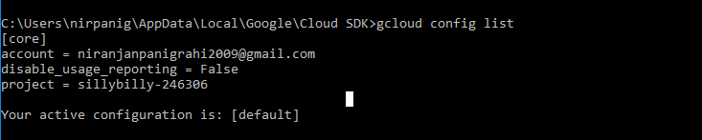

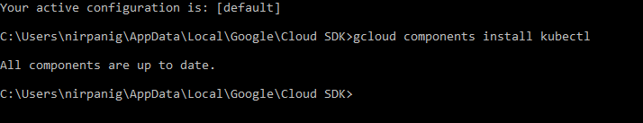

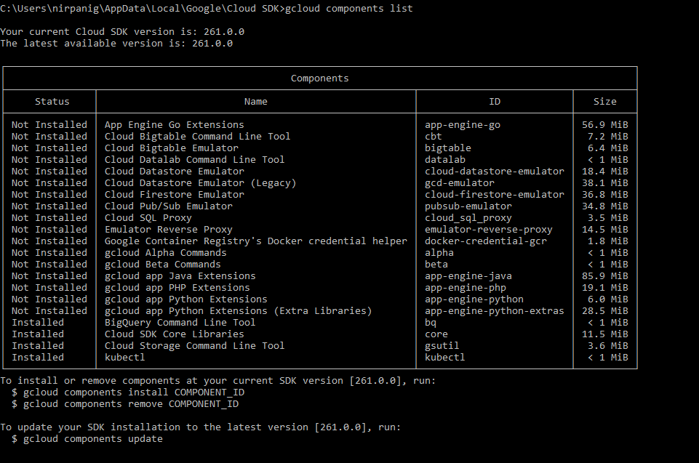

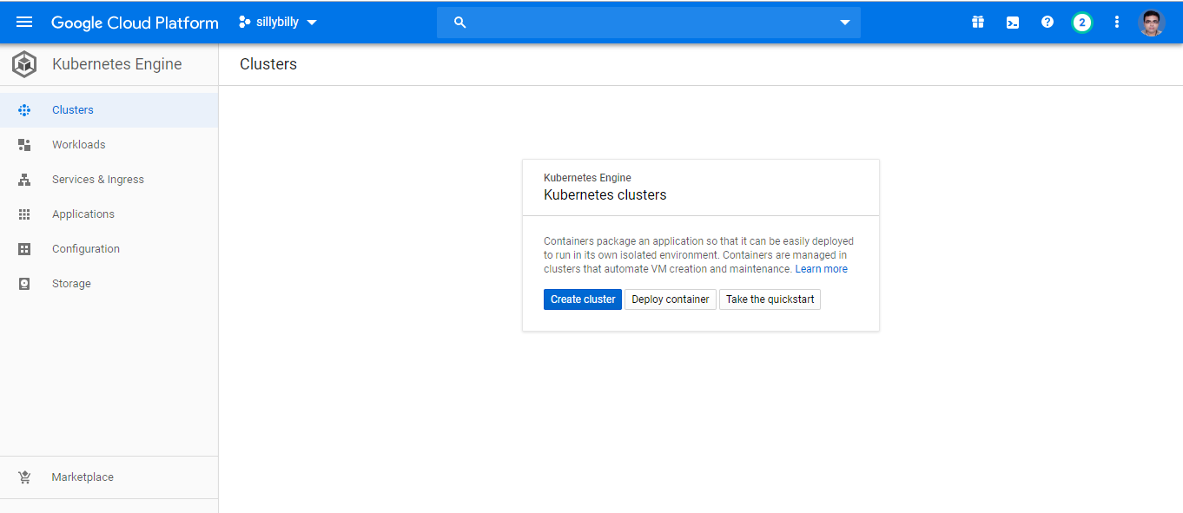

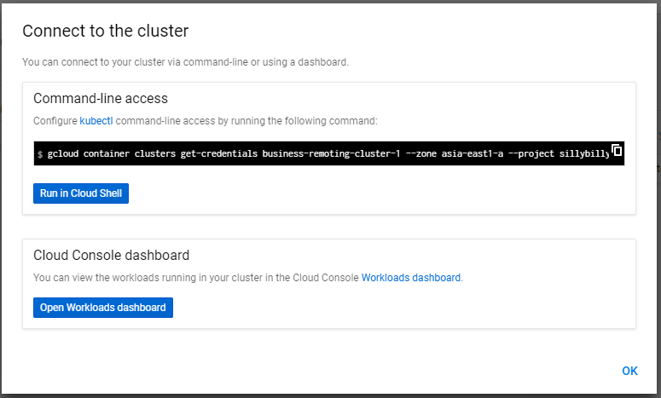

gcloud container clusters get-credentials business-remoting-cluster-1 --zone asia-east1-a --project sillybilly-246306

C:\Users\nirpanig\AppData\Local\Google\Cloud SDK>gcloud container clusters get-credentials business-remoting-cluster-1 --zone asia-east1-a --project sillybilly-246306

Fetching cluster endpoint and auth data.

kubeconfig entry generated for business-remoting-cluster-1.

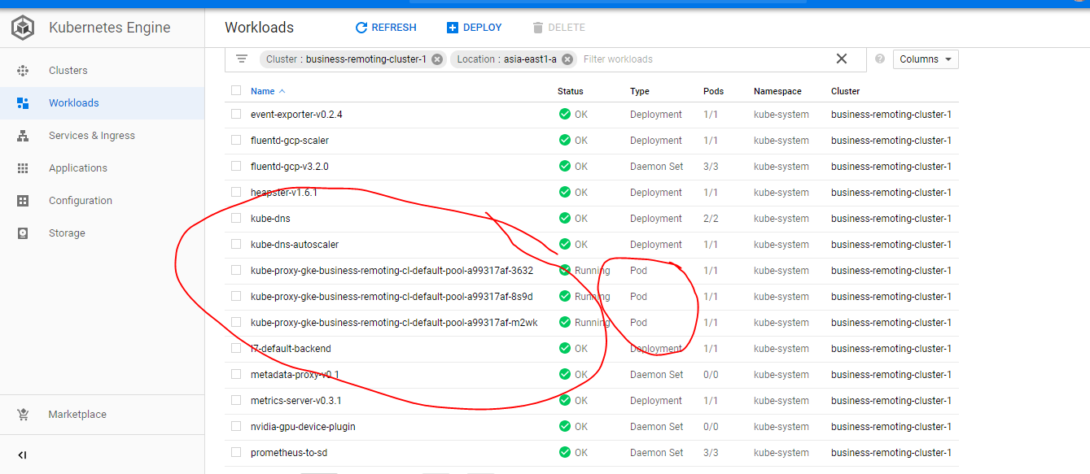

Can see all the running pods in workload tab

<https://cloud.google.com/container-registry/docs/pushing-and-pulling>

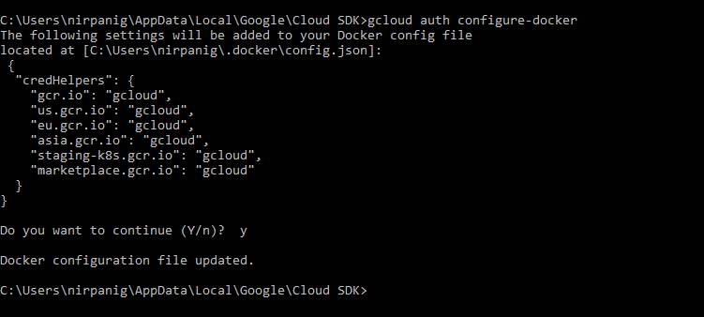

gcloud components install docker-credential-gcr

C:\project\oxygenworkspace\spring-micro-business-remoting>gcloud config set container/cluster business-remoting-cluster-1

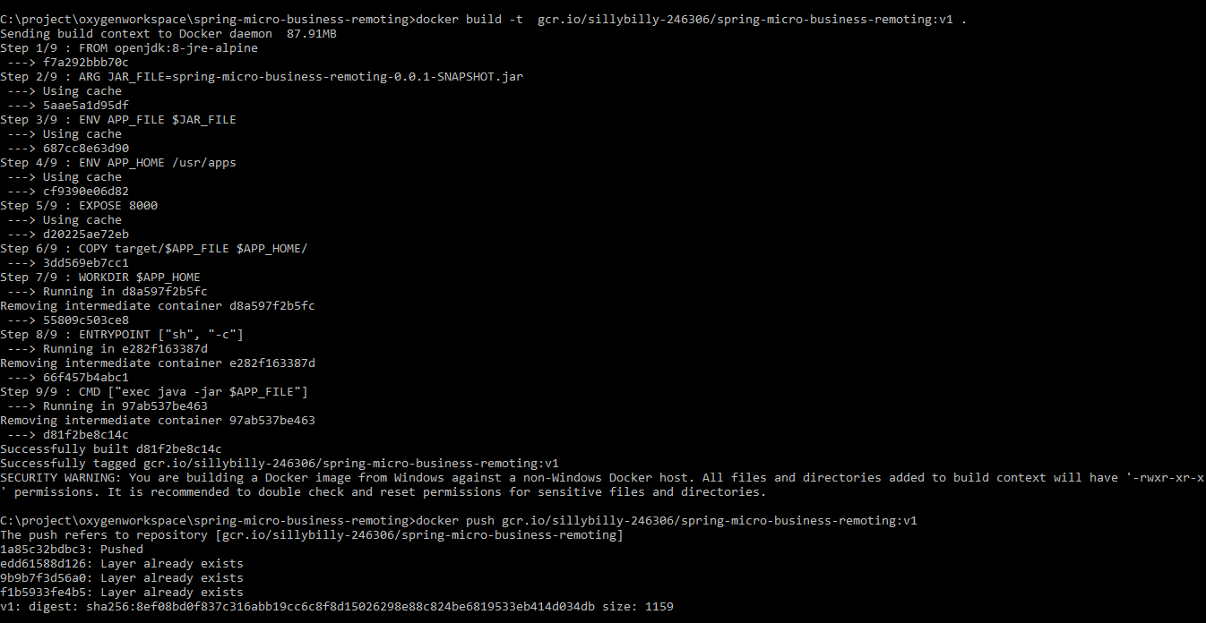

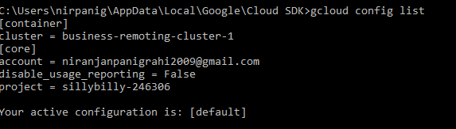

**Steps to deploy images to kubernates cluster**

C:\project\oxygenworkspace\spring-micro-business-remoting>kubectl run businessremotingdeployment --image=gcr.io/sillybilly-246306/spring-micro-business-remoting:v1 --port=8000

deployment.apps "businessremotingdeployment" created

C:\project\oxygenworkspace\spring-micro-business-remoting>kubectl expose deployment businessremotingdeployment --type="LoadBalancer"

service "businessremotingdeployment" exposed

C:\project\oxygenworkspace\spring-micro-business-remoting>kubectl get services

NAME TYPE CLUSTER-IP EXTERNAL-IP PORT(S) AGE

businessremotingdeployment LoadBalancer 10.107.15.119 <pending> 8000:30278/TCP 54s

kubernetes ClusterIP 10.107.0.1 <none> 443/TCP 1d

kubectl run log-exercise --image nginx

gcloud container clusters get-credentials business-remoting-cluster-1 --zone asia-east1-a --project sillybilly-246306 && kubectl get service businessremotingdeployment -o yaml

gcloud container clusters list

kubectl describe services businessremotingdeployment

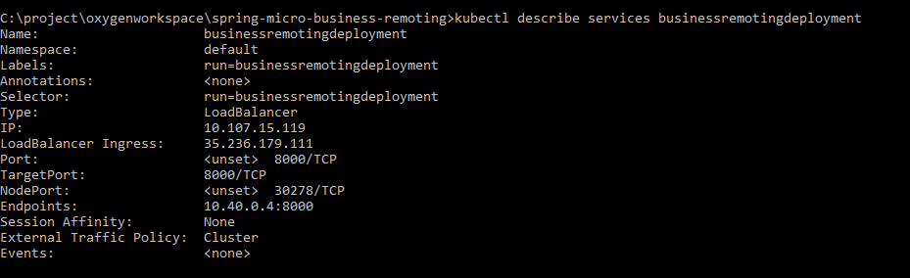



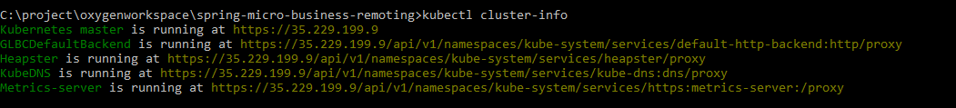

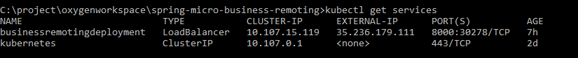

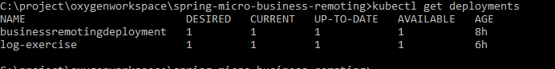

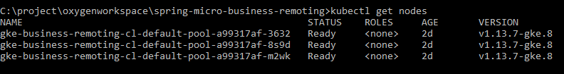

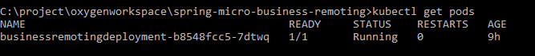

For example, the following command creates an autoscaling multi-zone cluster with six nodes across three zones, with a minimum of one node per zone and a maximum of four nodes per zone:

gcloud container clusters create example-cluster \

--zone us-central1-a \

--node-locations us-central1-a,us-central1-b,us-central1-f \

--num-nodes 2 --enable-autoscaling --min-nodes 1 --max-nodes 4



C:\project\oxygenworkspace\spring-micro-business-remoting>kubectl autoscale deployment businessremotingdeployment --min=2 --max=10 --cpu-percent=75

deployment.apps "businessremotingdeployment" autoscaled